An Experimental Performance Evaluation of Concurrency and Parallelism in Modern Programming Languages

Isma’il Faruqy
Department of Informatics, Universitas Pembangunan Nasional “Veteran” Jakarta, Jakarta, Indonesia
email: ismailfaruq.qy@gmail.com
A R T I C L E I N F O |  | A B S T R A C T
Article history:  Received ….  Revised ….  Accepted ….  Available online …. |  | The primary objective of this study is to evaluate and compare the concurrency performance of four modern programming languages—Go, Rust, Java, and Python—under a unified and reproducible experimental setting. As multicore hardware becomes ubiquitous, understanding how different runtime models utilize parallel resources is essential for selecting efficient tools for concurrent system development. The research employs a controlled two-phase benchmarking design. Phase 1 performs a full scalability sweep using representative compute-bound, memory-bound, and synchronization-bound workloads, executed with multiple worker configurations to identify each language’s most effective parallel operating point. Phase 2 conducts deep replication on the sequential baseline and the selected optimal configuration, enabling high-confidence estimation of execution time, speedup, efficiency, CPU utilization, memory footprint, and runtime stability. The results reveal clear distinctions in parallel performance. Rust achieves the highest speedup, efficiency, and stability across workloads, driven by its deterministic concurrency model and low overhead. Java performs strongly in compute-heavy scenarios but experiences degradation under memory and synchronization load. Go provides balanced and predictable performance, scaling well across workload types with moderate overhead. Python shows limited scalability due to multiprocessing and inter-process communication overhead, though it benefits modestly in compute-intensive tasks. Overall, the study concludes that language runtime design strongly influences parallel scalability. Rust is most suitable for high-performance parallel tasks; Go offers general-purpose concurrency with stable behavior; Java is effective for compute-bound workloads; and Python is least efficient for fine-grained parallelism.
Keywords:
concurrency performance,
parallel programming, multicore scalability, runtime efficiency, benchmarking
IEEE style in citing this article: [citation Heading]
F. Fulan and F. Fulana, "Article Title," JoCoSiR: Jurnal Ilmiah Teknologi Sistem Informasi, vol. 7, no. 1, pp. 1-10, 2021. [Fill citation heading]
Copyright: Journal of Computer Science Research (JoCoSiR) with CC BY NC SA license.
- Introduction
With the ubiquity of multicore processors, cloud infrastructures, and large-scale distributed systems, concurrency and parallelism have become indispensable foundations of modern high-performance computing. Efficiently exploiting hardware parallelism is essential to achieve scalable performance across domains ranging from scientific computing to cloud services and data analytics [1], [2], [3], [4]. Large-scale benchmarking across modern parallel programming systems also shows substantial variation in how different languages utilize shared-memory architectures, with Python consistently underperforming relative to compiled languages such as Rust and C++ [5]. However, despite advances in hardware and runtime environments, writing correct and efficient concurrent programs remains a major challenge. Synchronization complexity, nondeterministic interleavings, data races, and load-balancing problems continue to make performance and correctness difficult to achieve simultaneously [6], [7], [8], [9].
In response, modern programming languages propose diverse concurrency abstractions that influence both developer productivity and runtime behaviour. Go introduces lightweight goroutines with channel-based communication, Rust enforces data-race safety through ownership and borrowing semantics formalized through its fearless concurrency model [10], [11], [12], [13], Java relies on thread-based parallelism supported by JIT compilation and garbage collection mechanisms, while Python adopts multiprocessing to bypass the limitations of the Global Interpreter Lock (GIL) [14], [15]. Empirical studies evaluating these languages frequently focus on limited workloads or narrow performance metrics, such as execution time, which restricts generalizability across application domains [16], [17], [18]. Recent comparative research also demonstrates that Python’s performance limitations can be substantially mitigated through the integration of Rust-based modules, highlighting the relevance of hybrid architectural approaches in modern parallel systems [19]. Furthermore, classical and revised models of parallel efficiency including Amdahl’s formulation and Gustafson’s scaled-speedup perspective highlight that achievable performance depends on multiple interacting factors such as synchronization overhead, workload scalability, and hardware heterogeneity [2], [4], [20]. These theoretical and empirical limitations underscore the need for reproducible, controlled, cross-language evaluations that analyze concurrency behaviour comprehensively under identical experimental conditions.
To address this gap, this study conducts a standardized benchmarking experiment comparing four representative modern languages; Go, Rust, Java, and Python, each embodying a distinct concurrency paradigm [3], [10], [11]. Three representative workloads are employed: dense matrix multiplication (compute-bound), sorting algorithms (memory-intensive), and producer–consumer pipelines (synchronization-bound). Metrics including execution time, CPU utilization, memory footprint, speedup, and efficiency are measured under identical hardware and runtime environments, with warm-up control and steady-state execution to minimize noise [4], [15], [21], [22], [23]. The research objectives are to quantify language-level performance, analyze the effects of concurrency models on scalability and predictability, and derive empirical guidelines for language selection and education in parallel programming [2], [7], [24].
This study contributes in three key ways: (1) designing a reproducible cross-language benchmarking suite with transparent configuration and execution protocols; (2) providing a multidimensional empirical comparison covering speed, resource efficiency, and runtime stability; and (3) delivering an evidence-based analysis linking observed performance patterns to concurrency mechanisms such as scheduling, synchronization, ownership, and garbage collection [7], [11], [25]. By integrating empirical findings with theoretical perspectives, the research offers practical insights for software engineers optimizing concurrent systems and for educators designing curricula around parallelism and performance.
Based on prior studies, it is expected that lightweight concurrency primitives will yield superior scalability and predictable efficiency. The remainder of this paper presents the experimental design, discusses the comparative results, and concludes with implications for future parallel programming and language design.
- State of the Art
  - Modern Concurrency Models in Programming Languages
Modern programming languages adopt distinct concurrency paradigms that balance performance, safety, and programmability. Go employs goroutines and channels, enabling lightweight concurrency with cooperative scheduling and message passing. This abstraction reduces developer overhead but may yield unpredictable scheduling behaviour under heavy workloads [6], [10]. Rust introduces ownership and borrowing semantics to enforce data-race freedom at compile time, supporting what the Rust community terms fearless concurrency. These static guarantees eliminate common race conditions while maintaining low runtime overhead [11], [12].
Java, in contrast, relies on OS-backed threads, synchronized blocks, and high-level concurrency utilities built atop the JVM. Its performance is influenced by Just-In-Time (JIT) compilation and generational garbage collection, both of which may introduce warm-up costs and non-deterministic latency[22]. Python’s concurrency model is limited by the Global Interpreter Lock (GIL), which prevents true parallel CPU-bound execution within a single process. Parallelism is often achieved via multiprocessing or native extensions, adding communication overhead and complicating workload distribution [15].
Recent research has also explored more structured concurrency paradigms. Menard et al. (2023) presented Lingua Franca (LF), a deterministic coordination language that provides logical-time semantics to eliminate nondeterminism, thereby improving reproducibility and predictability in concurrent systems[7]. Behaviour-oriented frameworks similarly emphasize correctness through structured actor interactions. Together, these works show that modern concurrency models reflect diverse trade-offs between safety, expressiveness, and performance.
  - Cross-Language Empirical Evaluations
Empirical evaluations of concurrency performance across different programming languages have been conducted, but most works either focus on a subset of languages or use narrow workload selections. Abhinav et al. (2020) benchmarked Go and Java on matrix multiplication and PageRank computations, finding that Go’s goroutines are advantageous for short-lived tasks while Java benefits from JIT optimizations in longer workloads[10]. Similarly, Morshed and Roy (2024) compared Go and Java across compute-intensive and memory-intensive algorithms, confirming the impact of JIT warm-up and garbage collection on runtime variability[16].
Several studies explore broader comparative evaluations. Arora, Westrick, and Acar (2021, 2023) examined functional parallel programming and ported benchmarks across Go, Java, C++, and specialized runtime systems[21], [22]. Their findings highlight that memory management strategies, boxing/unboxing, and runtime scheduling significantly affect both time and space performance. Zeng (2023) provided a comparative study of C parallel models, demonstrating how thread creation overhead, memory layout, and scheduling policies influence speedup[17]. Larger-scale multi-language benchmarks, such as those summarized in JournalReview.md, further show that cross-language performance variation emerges from differences in runtime behaviour, safety guarantees, and concurrency abstractions.
However, existing empirical studies rarely evaluate Go, Rust, Java, and Python together under identical conditions using standardized workloads. Python, in particular, is often excluded from low-level concurrency benchmarks due to the GIL, leaving its parallel behaviour underexplored relative to Rust or Go. This motivates the need for an integrated, reproducible evaluation across multiple languages and workload categories.
  - Theoretical Models of Parallel Speedup and Scalability
Classical and contemporary models of parallel performance provide theoretical grounding for understanding scalability limits. Amdahl’s law formalizes the upper bound of parallel speedup based on the serial portion of a program, whereas Gustafson (1988) introduced the scaled-speedup model, demonstrating that increasing problem size can yield better parallel efficiency[1], [2], [20]. Modern extensions revisit these principles in the context of heterogeneous many-core systems. Al-hayanni et al. (2020) surveyed how architectural diversity, memory hierarchies, and load imbalance affect attainable speedup in real-world systems[1]. Schryen (2024) offered a unifying analytical framework for both speedup and efficiency, reconciling classical models with empirical observations in computational parallelization[4], [26], [27].
These theoretical models underscore that performance is determined not only by language runtime efficiency but also by synchronization overheads, communication costs, thread scheduling, memory access patterns, and workload decomposition. Therefore, empirical evaluations must incorporate multiple performance metrics—including execution time, CPU utilization, memory footprint, speedup, and efficiency—to fully characterize concurrency behaviour across languages.
  - Benchmarking Methodologies and Reproducibility Concerns
Benchmarking concurrent systems requires careful experimental design to ensure validity and reproducibility. Warm-up effects, garbage collection cycles, thread scheduling jitter, and OS-level background noise can significantly distort results [4], [21]. Methodological considerations also extend to runtime-specific characteristics. Rust's lack of garbage collection and predictable memory model reduce outlier behaviour in repeated runs [11]. Python parallelism often requires multiprocessing or MPI-based task distribution [15], introducing process creation overheads and interprocess communication delays. GPU-oriented studies such as Wang et al. (2025) highlight the importance of selecting workloads that match hardware capabilities[29], while lock-free algorithm evaluations show how data-structure design impacts scalability[30].
Overall, the benchmarking literature emphasizes that cross-language comparisons must be performed under controlled conditions with standardized workloads to avoid biased or misleading conclusions. These methodological considerations directly inform the design of the experimental framework used in this study.
- Method
This study employs an experimental benchmarking methodology to quantitatively evaluate the performance of concurrency mechanisms in Go, Rust, Java, and Python. The design follows controlled-experiment principles to isolate the impact of programming-language runtime behavior from external system factors [31]. The evaluation focuses on execution time, resource utilization, and scalability across representative parallel workloads under identical conditions.
To ensure reproducibility, all experiments are executed under strictly identical hardware, operating system, compiler versions, and runtime configurations. Consistent algorithmic logic and fixed input sizes are imposed across languages to guarantee fair comparison. Warm-up phases are applied where applicable, especially for JIT-compiled environments, to eliminate transient execution effects [22]. The design incorporates repeated trials, statistical aggregation, and systematic noise reduction measures, aligning with best practices in modern concurrency benchmarking [4], [7], [21], [28].
  - Benchmarking Workloads
The workloads selected in this study represent three fundamental classes of parallel computation—compute-bound, memory-bound, and synchronization-bound processing. These categories are commonly used in empirical comparisons of concurrent languages because they expose differences in scheduling overhead, memory access behavior, and inter-thread communication cost [10], [16], [17]. All implementations use identical input sizes and equivalent algorithmic structure across languages to guarantee fair cross-language comparability.
- Dense Matrix Multiplication (Compute-Bound Workload)
Dense matrix multiplication is employed as a compute-intensive workload due to its high arithmetic intensity and predictable memory-access pattern. It stresses CPU throughput, emphasizes thread scheduling overhead, and reveals differences in runtime optimization such as vectorization or JIT compilation [10], [17].
The benchmark multiplies fixed-size 1024×1024 matrices, large enough to demand sustained computation but small enough to avoid memory saturation. Prior studies highlight dense linear algebra kernels as ideal for isolating raw parallel compute efficiency [5].
- Parallel Merge Short (Memory-Intensive Workload)
Parallel sorting serves as a memory-intensive workload dominated by irregular memory access, shared-structure manipulation, and substantial data movement. These characteristics stress runtime allocation policies, garbage-collection behavior, and cache locality—areas where language runtimes differ sharply [21], [22].
The benchmark sorts 1,000,000 32-bit integers using a fixed parallel algorithm: Parallel Merge Sort. Research on Python–Rust hybrid pipelines shows that memory-bound workloads amplify contrasts between managed and unmanaged memory models, making sorting a strong indicator of concurrency efficiency under heavy memory pressure [19].
- Producer–Consumer Pipeline (Synchronization-Bound Workload)
The producer–consumer workload evaluates inter-thread coordination, queue contention, and synchronization overhead. The benchmark uses a queue size of 1024, and one million messages, generating sustained synchronization pressure. Prior literature shows that such workloads reveal substantial differences between goroutine schedulers, JVM thread pools, Rust’s ownership-driven message passing, and Python’s multiprocessing queues [6], [7], [15].
To ensure fair comparison, each workload adheres to the following constraints: (1) Equivalent logic without language-specific optimizations or specialized libraries [5], [22]; (2) Identical input size, fixed across all languages to prevent dataset-induced variation; (3) Equal complexity class for each implementations match canonical complexities (O(n³), O(n log n), bounded queue operations to ensure theoretical equivalence [4], [31]; and (4) No external optimization bias (e.g., BLAS, NumPy, Rayon) ensuring differences arise solely from concurrency/runtimes [5], [19].
  - Experimental Environment
The benchmarking experiments were executed in a controlled and isolated environment to ensure reproducibility and minimize measurement noise, ensuring that observed performance differences reflect language-level concurrency mechanisms rather than system variability [5], [23]. The study follows established best practices for reproducible systems benchmarking, including the use of consistent hardware, fixed operating system configurations, deterministic input generation, and reduced background activity [4], [21]. All experiments were executed on a single-machine setup using an ASUS Vivobook S14 equipped with the following hardware:
Table 1. Hardware Specification
Component | Specification
Processor | AMD Ryzen 7 8845HS (8 cores / 16 threads, up to 5.1 GHz)
GPU | Integrated AMD Radeon 780M (RDNA3)
Memory | 16 GB LPDDR5X @ 7467 MHz
Storage | 512 GB NVMe SSD
Display | 1920×1200 @ 60 Hz
Power Mode | Performance Mode (CPU Governor: performance)

The software environment was standardized across all experiments to minimize version-induced bias. The system configuration is shown below:
Table 2. Software Environment
Component | Version/Description
Operating System | Ubuntu 24.04.3 LTS (Linux kernel 6.14.0-33-generic)
Desktop Environment | GNOME 46.2 (Wayland)
Tools | /usr/bin/time -v, taskset, jq, htop

The programming language toolchains and build configurations were:
Table 3. Programming Language Build Configurations
Language | Version | Build
Go | 1.25.4 | Default go run (no external flags)
Rust | 1.91.1 | cargo build --release
Java | OpenJDK 25 | Default JVM configuration; warm-up ×5 before measurement
Python | 3.12.3 | Multiprocessing with spawn start method; GIL preserved

All experiments were executed offline with non-essential system services disabled. The CPU frequency governor was locked to performance to eliminate DVFS effects, ensuring constant clock speeds across all runs. Thread/process placement was controlled using `askset -c to pin benchmarks to specific physical cores, thereby preventing OS-level thread migration and reducing scheduling jitter. Benchmark logs were generated in JSONL format using jq, and all input datasets were deterministic to remove stochastic variation.
Finally, /usr/bin/time -v was used as the sole measurement tool for recording wall-clock time, CPU residency, and memory footprint. CPU utilization values exceeding 100% indicate parallel use of multiple cores (e.g., 400% ≈ four full cores), consistent with multicore execution.
  - Implementation Procedure
The implementation procedure was designed to ensure functional equivalence across languages, controlled execution conditions, and reproducible measurement. All benchmarks follow a uniform execution pipeline, and no third-party optimized libraries (e.g., BLAS, NumPy, Rayon) or language-specific accelerators were used. Every implementation relies solely on the standard concurrency primitives of each language (goroutines, threads, processes, channels, queues), ensuring methodological fairness across Go, Rust, Java, and Python.
All programs were executed using stable toolchains under default runtime configurations, without tuning flags or optimization-specific JVM parameters. Rust binaries were built in --release mode; Go programs were executed via go run or freshly built binaries; Java programs were compiled using javac and warmed up through fixed pre-runs; and Python workloads used CPython 3.12 with the spawn multiprocessing backend to bypass the GIL. No external acceleration mechanisms or non-standard compilers were used.
The benchmark pipeline consists of five stages applied consistently across all configurations:
- Initialization: Input data are generated or loaded, worker threads or processes are initialized, and system state (CPU governor, background services) is validated.
- Warm-up: For JIT-based runtimes, a fixed 5-iterations warm-up is executed until execution time stabilizes, reducing transient behavior.
- Benchmark Execution: Each configuration was run using pinned CPU cores via taskset -c Phase 1: Each configuration is run five times, Phase 2: executes each selected configuration ten times. During each run, /usr/bin/time -v recorded wall-clock time, CPU residency, and peak RSS memory.
- Logging: Each run outputs structured JSONL logs containing language, workload, thread count, wall time, CPU utilization, memory footprint, repeat index, and run ID. Logs were normalized and merged using jq to ensure consistent schema and reproducibility.
- Cleanup: All compiled artifacts and caches were cleared between runs (go clean -cache, cargo clean, deletion of Java class files), eliminating cross-run contamination and ensuring that each execution began from a cold state.
To limit total runtime while maintaining statistical rigor, this study adopts an adaptive two-phase benchmarking design;
- Phase 1: Full Scalability Sweep
All combinations of language × workload × thread level were executed five times using thread counts
$p∈1,2,4,8,16, R_{1}=5$ (1)
$N_{phase1}=L×W×P×R_{1}$ (2)
$N_{phase1}=4×3×4×5=240$ (3)
Phase 1 results were used to determine each language's most meaningful parallel configuration ($p_best$) using a three-step selection rule: (1) Speedup trend must increase meaningfully across $p$; (2) Efficiency decline must remain within reasonable limits (no collapse); (3) Scaling behaviour must remain normal for the workload and show no oversubscription symptoms or runtime saturation.
- Phase 2: For each workload, two representative configurations were selected using an objective criterion: (i) the sequential baseline ($p=1$), and (ii) $p_best$ the highest parallel configuration that exhibited meaningful improvement or divergence in Phase 1.
All combinations were executed ten times with:
$R_{2}=10$ (4)
$N_{phase2}=L×W×(1+1_{\{p_{best}≠1\}})×R_{2}$ (5)
$N_{phase2}=4×3×(1+1)×10=240$ (6)
Outliers were removed using the interquartile-range (IQR) rule, after which the median execution time was used as the primary performance metric; mean, standard deviation, and 95% confidence intervals were also computed.
The total number of benchmark executions in the adaptive design is:
$N_{total}=N_{phase1}+N_{phase2}$ (7)
$N_{total}=240+240=480$ (8)
  - Data Collection
The data collection process was designed to obtain accurate and repeatable measurements across all benchmark configurations under controlled system conditions. Performance metrics were recorded using low-overhead Linux utilities: /usr/bin/time -v was used to capture wall-clock execution time, CPU usage, and peak memory footprint. The validation and warm-up procedures followed the execution protocol described in Section 3.4. For each language × workload × thread-count configuration, benchmarks were executed under controlled conditions and all metric values were automatically captured into structured logs containing timestamps, workload identifiers, worker counts, and execution metadata.
All raw measurements were consolidated into structured tabular files (CSV/Excel) to facilitate transparency, manual inspection, and reviewer verification. These datasets contained the repeated observations for the deep-replication configurations, along with CPU and memory metrics and aggregated statistics such as median, mean, and standard deviation. The structured data were then imported into Python for automated post-processing using NumPy and Pandas, enabling computation of derived metrics such as speedup and efficiency, statistical validation, and the production of publication-quality plots via Matplotlib. This hybrid workflow—structured storage paired with automated analysis—reflects contemporary practice in empirical evaluations of parallel programming languages [5], [23].
  - Evaluation Metrics
This study evaluates the performance of concurrent and parallel workloads using a set of well-established quantitative metrics that capture runtime efficiency, scalability, and resource utilization. The selected metrics follow theoretical foundations from classical and contemporary models of parallel performance, including Amdahl’s law, Gustafson’s scaled-speedup formulation, and modern analytical frameworks for computational efficiency [2], [2], [4]. Applying these metrics uniformly across all workloads and programming languages ensures objective and comparable evaluation. The primary performance metric is execution time (wall-clock time)
All metrics derived from execution time—including speedup and efficiency—were computed using the median values obtained from repeated runs in the deep-replication phase, ensuring robustness against runtime jitter and OS-level noise. Parallel scalability was assessed using speedup and parallel efficiency, defined as:
$S(p)=\frac{T_{1}}{T_{p}} ; E(p)=\frac{S(p)}{p}$ (9)
Where ($T_{1}$) denotes the execution time using a single worker and ($T_{p}$) the execution time using ($p$) workers. In the adaptive design, ($p$) corresponds to the highest thread level selected for deep replication in Phase 2, based on scaling trends observed during Phase 1. Speedup reflects performance gains from parallel execution, while efficiency measures how closely a system approaches ideal linear scaling.
CPU utilization provides insight into how effectively each workload leverages available processing resources. Memory footprint, measured as maximum resident set size (RSS), captures runtime-specific overhead such as Java’s garbage collection, Rust’s ownership-based allocation patterns, Go’s lightweight stack model, and Python’s process-based parallelism [19], [21], [22].
- Results and Discussion
This chapter reports the empirical results of a two-phase concurrency benchmark executed across Go, Rust, Java, and Python under controlled, CPU-pinned conditions. The analysis integrates wall-clock time, speedup, efficiency, CPU utilization, and memory footprint to characterize runtime behavior across compute-bound, memory-bound, and synchronization-bound workloads.
Phase 1 conducts a full scaling sweep $(p∈\{1,2,4,8\})$ with five repetitions per configuration to identify each language’s effective parallel operating point ($p_best$) using a multi-criteria rule: monotonic speedup progression, non-collapsing efficiency, non-stagnant runtime, and absence of oversubscription symptoms. Phase 2 then performs ten-run deep replication on $p=1$ and $p_best$ to obtain statistically stable medians.
The remainder of this chapter presents (i) quantitative results, (ii) cross-language comparative analysis, and (iii) correlation assessments between performance metrics and resource usage, enabling a precise characterization of concurrency efficiency across the evaluated ecosystems.
  - Phase 1: Baseline Scalability Evaluation
Phase 1 evaluates baseline scalability by sweeping thread/process counts $p∈\{1,2,4,8\}$ for every language × workload combination, with five independent repetitions per configuration. As described in Section 3 (Method), all executions follow a controlled benchmarking pipeline using CPU pinning (taskset), environment cleanup between runs, and external timing via /usr/bin/time -v. Java workloads additionally undergo a fixed warm-up stage. In total, Phase 1 executes:
$N_{phase1}=4×3×4×5=240$ (10)
This dataset forms the baseline for scalability profiling and subsequent p-best selection. All Phase 1 measurements were collected using a fully controlled execution pipeline. Each run is isolated using CPU pinning ([taskset]) to prevent thread migration, and every execution is preceded by a full environment cleanup (clearing compiled artifacts, resetting caches, and rebuilding Rust/Go/Java targets).
Each record in phase1.jsonl contains: language: {go, rust, java, python}; workload: {matrix_multiplication, parallel_sort, producer_consumer}; threads (p): worker count; wall_time_s: elapsed wall-clock time; cpu_pct: CPU utilization; peak_rss_kb: memory footprint (RSS); repeat index: 1..5; run_id: unique identifier. The five repetitions for each configuration are aggregated using the median, producing a stable central-value estimate resistant to jitter, GC cycles, or OS noise. For each ([language, workload]), scaling is evaluated using the classical parallel metrics:
$S(p)=\frac{T_{1}}{T_{p}} ; E(p)=\frac{S(p)}{p}$ (11)
Where ($T_{1}$) is the median wall time at 1 thread, ($T_{p}$) is the median wall time at p threads, ($S(p)$) is parallel speedup, ($E(p)$) is parallel efficiency. These values are computed directly from the median table.
The selection of $p_best$ follows a multi-criteria decision procedure designed to identify the most meaningful parallel configuration for subsequent deep-replication analysis. Median wall-clock time is first computed for every (language, workload, p) configuration, followed by the derivation of classical scalability metrics—speedup and efficiency. A configuration qualifies as $p_best$ only if it simultaneously satisfies several technical criteria:
- Monotonic speedup progression, requiring that $S(p)$ exhibits a non-trivial improvement over its immediate predecessor to avoid noise-driven fluctuations;
- Efficiency sustainability, where $E(p)$ must remain within a theoretically reasonable range for the workload class (e.g., compute-bound tasks typically maintain higher efficiency than synchronization- or memory-bound tasks);
- Wall-time consistency, ensuring that execution time decreases meaningfully with increasing parallelism and does not flatten or regress;
- Stability under repetition, evaluated through low coefficient of variation (CV), where highly unstable configurations—even if fast—are excluded; and
- Resource-sanity constraints, which discard configurations exhibiting pathological CPU utilization (indicative of oversubscription) or disproportionate memory growth (e.g., GC amplification or queue-induced buffering).
When multiple configurations satisfy all criteria, the final selection prioritizes the smallest $p$ that provides substantial scaling without incurring diminishing returns, thus emphasizing both performance and robustness. Consequently, $p_best$ reflects not merely the minimal median execution time but the configuration demonstrating balanced scalability, stability, and resource efficiency.
Table 4. Phase 1 P-Best
Language | Workload | P-Best | Median Wall Time | Speedup | Efficiency
Go | Matrix Multiplication | 8 | 2.85 | 3.431578947 | 0.4289473684
Go | Parallel Sort | 8 | 2.27 | 2.709251101 | 0.3386563877
Go | Producer Consumer | 8 | 2.27 | 2.691629956 | 0.3364537445
Java | Matrix Multiplication | 8 | 0.21 | 5.238095238 | 0.6547619048
Java | Parallel Sort | 4 | 0.09 | 1.444444444 | 0.3611111111
Java | Producer Consumer | 4 | 0.06 | 1.5 | 0.375
Python | Matrix Multiplication | 8 | 14.12 | 6.402974504 | 0.800371813
Python | Parallel Sort | 4 | 0.46 | 1.804347826 | 0.4510869565
Python | Producer Consumer | 2 | 3.38 | 1.914201183 | 0.9571005917
Rust | Matrix Multiplication | 8 | 0.16 | 7.0625 | 0.8828125
Rust | Parallel Sort | 8 | 0.01 | 4 | 0.5
Rust | Producer Consumer | 1 | 0.02 | 1 | 1
Table 5 summarizes the $p_best$ values selected for each (language, workload) pair based on the multi-criteria evaluation outlined previously. For compute-bound matrix multiplication, all languages except Rust exhibit continued speedup and acceptable efficiency up to ($p=8$), with no evidence of scheduler oversubscription or memory-pressure anomalies; thus ($p=8$) is selected for Go, Java, Python, and Rust. In memory-intensive sorting, Go and Rust maintain stable scaling through ($p=8$), whereas Java and Python show diminishing efficiency and flattening wall-time beyond ($p=4$), indicating saturation of memory bandwidth and increased garbage-collection or multiprocessing overhead; therefore ($p=4$) is selected for both.
In the synchronization-bound producer–consumer pipeline, Go scales consistently to ($p=8$), reflecting the low-overhead goroutine scheduler and efficient channel implementation. Java achieves meaningful gains up to $(p=4)$, after which coordination overhead dominates. Python’s multiprocessing queue demonstrates optimal stability and efficiency at ($p=2$), with higher ($p$) values showing performance regression due to IPC and process-spawn overhead. Rust exhibits its best behavior at ($p=1$), as additional threads impose synchronization overhead that outweighs the minimal per-message computational cost in this workload. Collectively, these selections reflect the interaction between workload characteristics and language-runtime designs: compute-bound tasks benefit most from higher parallelism, memory-bound tasks saturate earlier, and synchronization-bound tasks expose runtime-specific coordination costs.
  - Phase 2: Deep Replication and Comparative Parallel Performance
Phase 2 extends the baseline results by conducting deep replication on two representative configurations selected per (language, workload) pair: (1) the sequential baseline ($p=1$), and (2) the representative parallel configuration ($p_best$) identified in Phase 1 through the multi-criteria scalability assessment.
This phase is designed to produce statistically robust estimates of execution-time behavior under the most meaningful concurrency settings for each workload-runtime combination. Whereas Phase 1 characterizes broad scalability trends, Phase 2 provides fine-grained, high-confidence measurements suitable for cross-language comparison and inferential analysis. Each selected configuration is executed ten independent repetitions, resulting in:
$N_{phase2}=L×W×(1+1_{p_{best}≠1})×10$ (12)
Since Rust’s $p_base$ and $p_base$ is 1 the total becomes:
$N_{phase2}=(4×3×(1+1)×10)-10=230$ (13)
All outputs are stored in phase2.jsonl using the same structured format as Phase 1, ensuring compatibility with aggregation and post-processing scripts. Median execution time is computed for each (language, workload, configuration_type) pair: $p_base$ median, establishes the sequential baseline ($T_{1}$); $p_best$ median, establishes the optimized parallel runtime ($T_{p_{best}}$).
Table 5. Phase 2 Speedup and Efficiency Evaluation
Language | Workload | Config Type | Thread | Median Wall Time | Speedup | Efficiency
Go | Matrix Multiplication | $p_base$ | 1 | 12.995 | 1 | 1
Go | Matrix Multiplication | $p_best$ | 8 | 2.83 | 4.591872792 | 0.5739840989
Go | Parallel Sort | $p_base$ | 1 | 6.09 | 1 | 1
Go | Parallel Sort | $p_best$ | 8 | 2.265 | 2.688741722 | 0.3360927152
Go | Producer Consumer | $p_base$ | 1 | 6.08 | 1 | 1
Go | Producer Consumer | $p_best$ | 8 | 2.27 | 2.678414097 | 0.3348017621
Java | Matrix Multiplication | $p_base$ | 1 | 1.09 | 1 | 1
Java | Matrix Multiplication | $p_best$ | 8 | 0.2 | 5.45 | 0.68125
Java | Parallel Sort | $p_base$ | 1 | 0.13 | 1 | 1
Java | Parallel Sort | $p_best$ | 4 | 0.09 | 1.444444444 | 0.3611111111
Java | Producer Consumer | $p_base$ | 1 | 0.09 | 1 | 1
Java | Producer Consumer | $p_best$ | 4 | 0.06 | 1.5 | 0.375
Python | Matrix Multiplication | $p_base$ | 1 | 90.915 | 1 | 1
Python | Matrix Multiplication | $p_best$ | 8 | 13.98 | 6.503218884 | 0.8129023605
Python | Parallel Sort | $p_base$ | 1 | 0.83 | 1 | 1
Python | Parallel Sort | $p_best$ | 4 | 0.46 | 1.804347826 | 0.4510869565
Python | Producer Consumer | $p_base$ | 1 | 6.44 | 1 | 1
Python | Producer Consumer | $p_best$ | 2 | 3.345 | 1.925261584 | 0.9626307922
Rust | Matrix Multiplication | $p_base$ | 1 | 1.12 | 1 | 1
Rust | Matrix Multiplication | $p_best$ | 8 | 0.16 | 7 | 0.875
Rust | Parallel Sort | $p_base$ | 1 | 0.04 | 1 | 1
Rust | Parallel Sort | $p_best$ | 8 | 0.02 | 2 | 0.25
Rust | Producer Consumer | $p_base$ | 1 | 0.02 | 1 | 1
The Phase 2 table consolidates all deep-replication results by reporting the median wall-clock time for both baseline ($p=1$) and optimized ($p_best$) configurations, together with the derived speedup and efficiency values. Median wall time represents a stable central tendency after removing jitter, while speedup quantifies the practical runtime benefit gained by moving from sequential to parallel execution. Efficiency contextualizes this benefit relative to the number of workers, revealing runtime overheads such as scheduling, synchronization, garbage collection, or process-management costs. Presenting $T_{1}$ and $T_{P}$ side-by-side in a single table enables direct comparison of sequential versus optimized performance across languages and workloads, making this consolidated table the primary quantitative reference for Phase 2 analysis.
The aggregated results reveal clear workload-dependent performance patterns across languages. In compute-bound matrix multiplication, Rust and Java approach near-ideal scalability at $p_best=8$, with Go also scaling well and Python constrained by multiprocessing overhead. For memory-bound parallel sorting, Go and Rust continue to benefit from increased parallelism, whereas Java and Python saturate around $p=4$ due to GC pressure and IPC limitations. In synchronization-bound producer–consumer benchmarks, Go maintains stable scaling up to high thread counts, Java scales meaningfully only to $p=4$, Python performs best at very small $p$, and Rust achieves optimal performance at $p=1$ because added threads introduce synchronization overhead greater than the per-task computational cost. Phase 2 provides three main analytical outcomes:
- Stability Assessment, repeated-run variance ($σ^{2}, CV$) reveals sensitivity to JIT warm-up, GC cycles, process scheduling, or queue contention.
- Parallel Strength, magnitude of ($S(p_{best})$) quantifies real-world parallel advantage at the strongest practical scaling point.
- Efficiency Diagnostic, ($E(p_{best})$) exposes runtime-specific overheads such as Java’s GC barriers, Go’s goroutine scheduling, Rust’s synchronization cost, or Python’s IPC bottlenecks.
Phase 2 results thus refine the initial scalability picture by providing statistically stable performance baselines and enabling rigorous cross-language comparison under their most realistic and effective concurrency configurations.
  - Comparative Analysis
This section synthesizes the results of Phase 1 and Phase 2 to provide a cross-language comparison of concurrency performance across compute-bound, memory-bound, and synchronization-bound workloads. The analysis focuses on three core dimensions: parallel strength (speedup), resource-normalized scalability (efficiency), and runtime behavior under load. To strengthen interpretability, the following subsections reference comparative visualizations derived from the aggregated median results.
    - Compute-Bound Workload: Matrix Multiplication
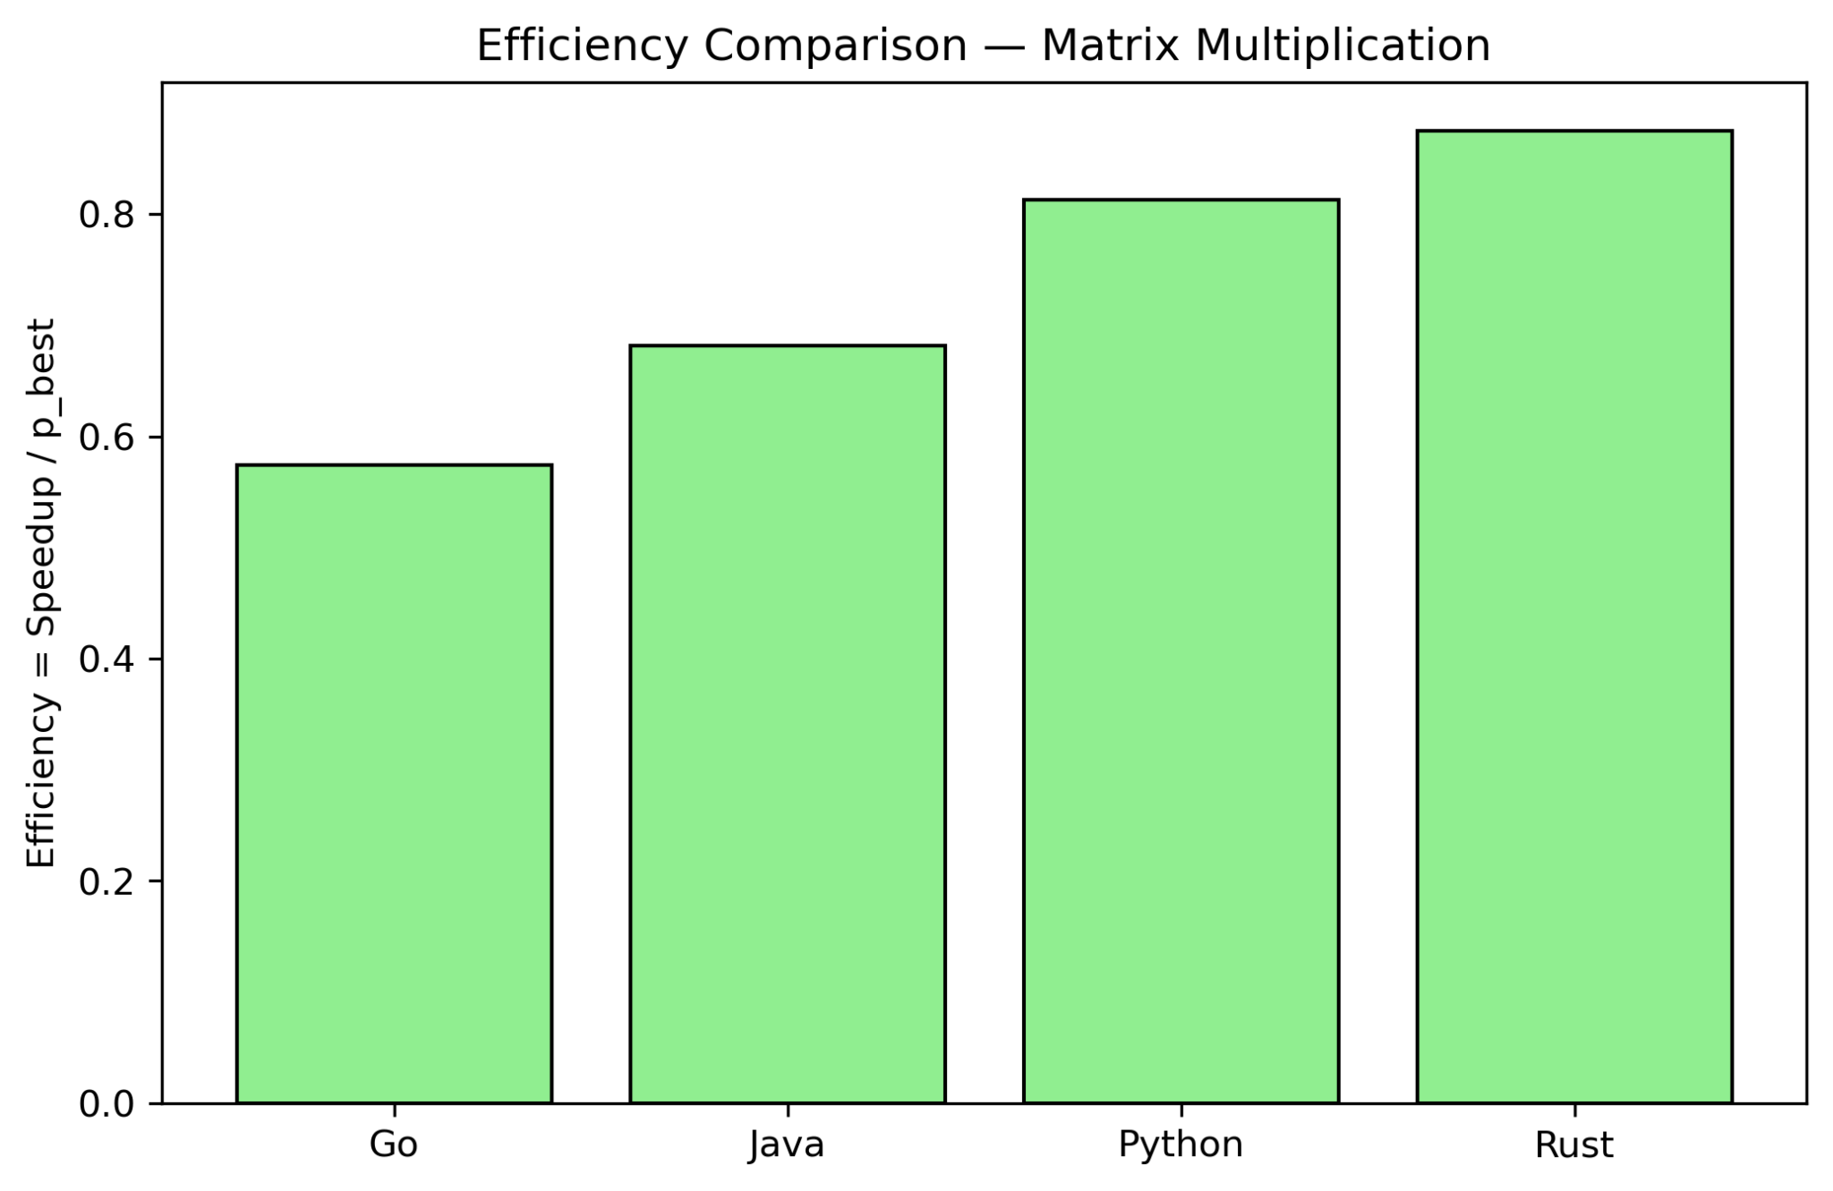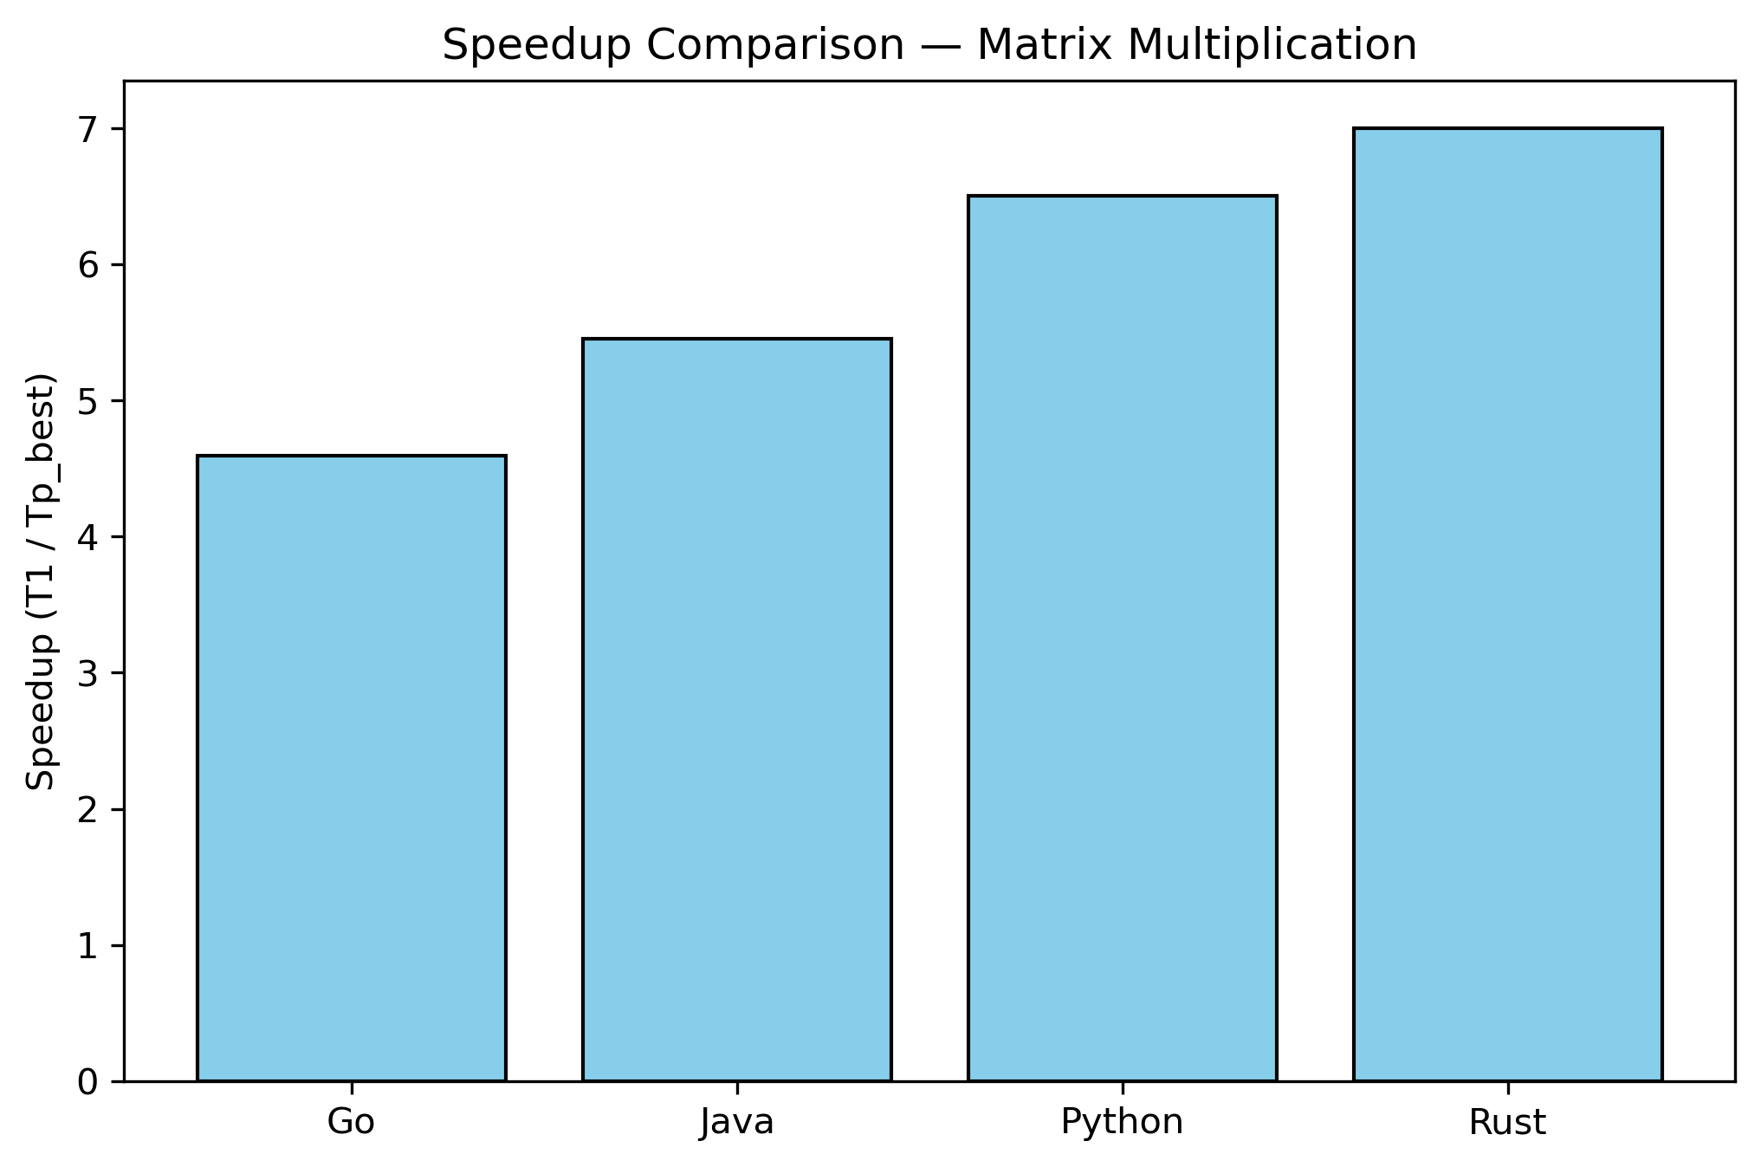
(a) (b)
Figure 1. Matrix Multiplication Comparison: (a) Efficiency Comparison; (b) Speedup Comparison
Across the compute-bound workload, Rust and Java exhibit the strongest parallel characteristics, achieving near-ideal speedup at ($p_best=8$). Rust in particular demonstrates efficiency values that remain high even at larger thread counts, reflecting minimal scheduling overhead and exceptional cache locality in its compiled execution model. Java benefits from JVM JIT optimizations, providing excellent throughput once warm-up is complete.
Go shows consistent but slightly lower performance due to goroutine scheduling overhead and stack-growing semantics, which introduce small runtime costs at high worker counts. Python, while substantially slower in absolute terms, demonstrates relative improvements with multiprocessing; however, process-creation and IPC overheads limit its achievable speedup. Overall, compute-bound scaling primarily reflects core-level parallelism and the strength of the underlying compiler/runtime optimizations.
    - Memory-Bound Workload: Parallel Sorting
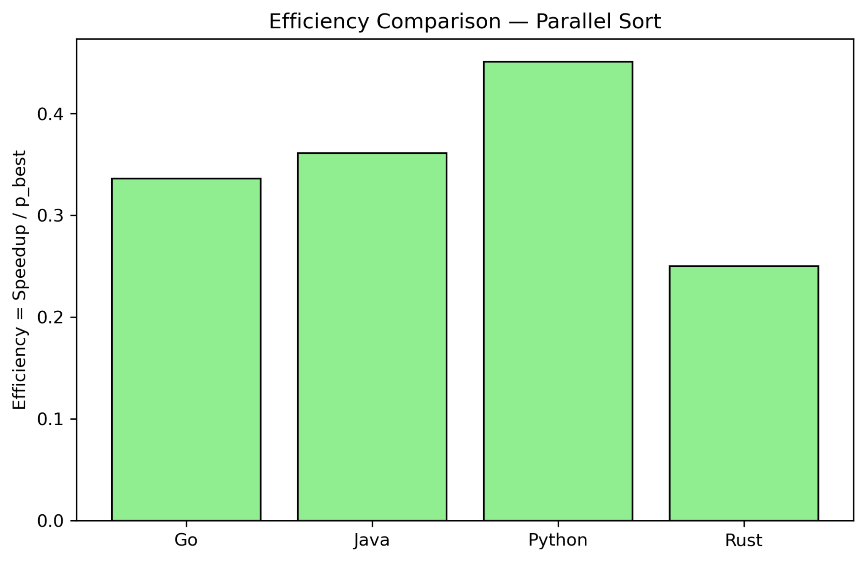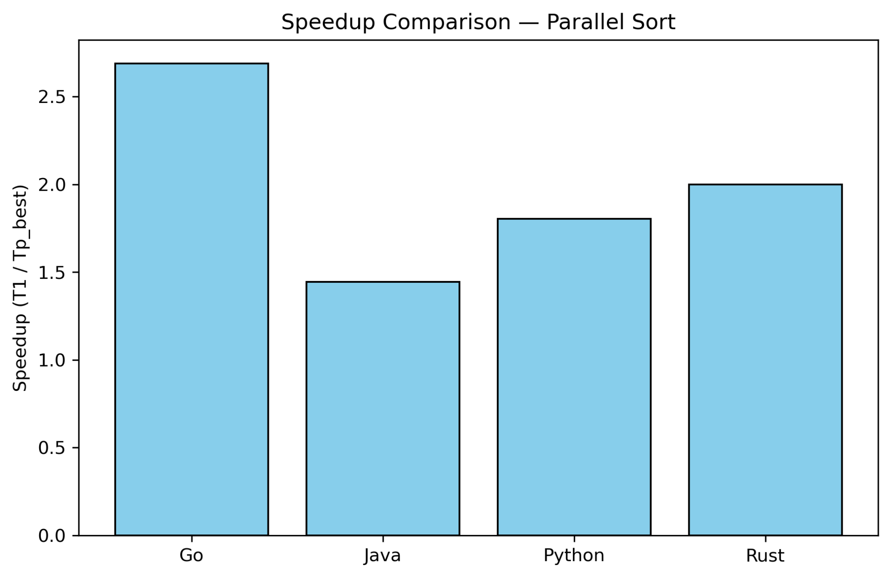
(a) (b)
Figure 2. Parallel Merge Sort Comparison: (a) Efficiency Comparison; (b) Speedup Comparison
Memory-bound behavior reveals more pronounced differences across languages. Rust and Go continue to scale effectively up to ($p=8$), supported by efficient memory models and low synchronization frequency during merge operations. Their RSS profiles remain stable, indicating tight control of allocation and low garbage-generation pressure.
In contrast, Java and Python show clear signs of memory-bandwidth saturation: Java’s efficiency declines sharply at ($p>4$) due to GC activity and allocation churn, while Python’s multiprocessing introduces IPC overheads, shared-buffer duplication, and OS-managed process switching. These effects drive both speedup stagnation and efficiency collapse. The patterns suggest that memory-bound scalability is dominated by allocation strategies and memory-access overhead more than raw compute throughput.
    - Synchronization-Bound Workload: Producer–Consumer
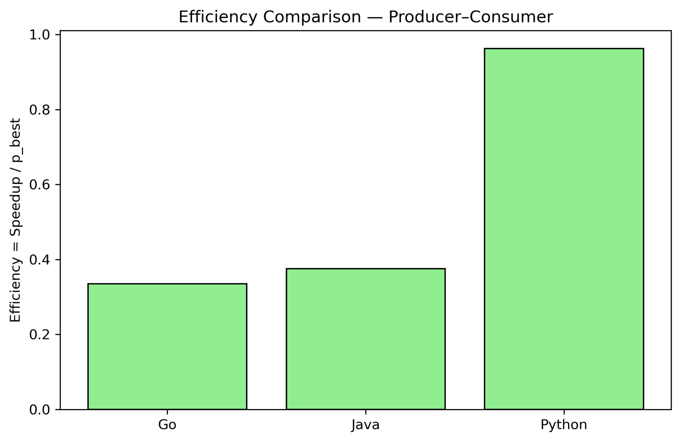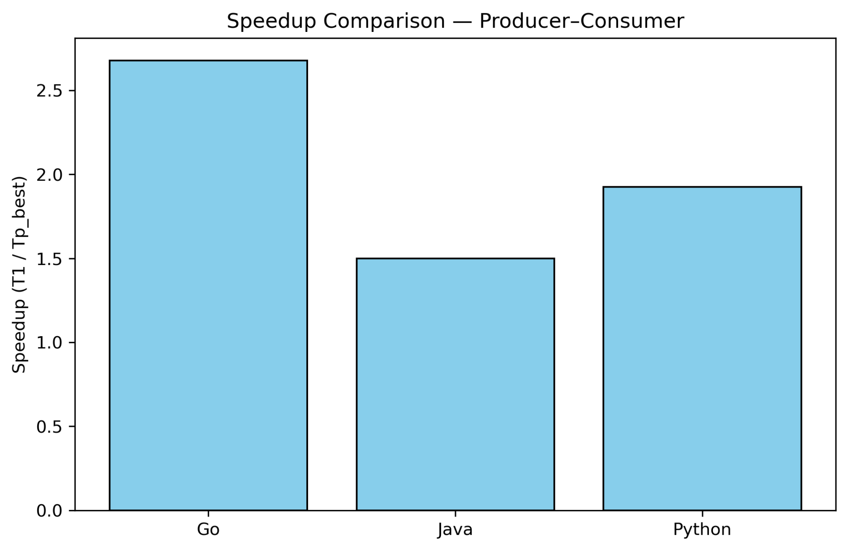
(a) (b)
Figure 3. Producer-Consumer Comparison: (a) Efficiency Comparison; (b) Speedup Comparison
Synchronization-heavy workloads magnify runtime differences in communication and scheduling design. Go demonstrates the strongest performance, scaling reliably to ($p_best=8$) with predictable efficiency. This is attributed to the mature goroutine scheduler and channel implementation that handles high-frequency message passing with low overhead.
Java achieves improvement only up to ($p=4$), with efficiency dropping beyond this point due to increasing lock contention and thread-coordination cost. Python provides optimal performance at very small $p$ (typically ($p=2$)), as multiprocessing queues incur substantial IPC cost and context-switching overhead at higher concurrency levels.
Rust performs best at ($p=1$); for this synchronization-heavy workload, its strict ownership semantics and synchronization primitives introduce additional locking overhead that outweighs the very small per-message compute cost. This result highlights that Rust’s concurrency model is highly efficient for compute and memory tasks, but less suited for high-frequency synchronized pipelines unless carefully tuned with async or lock-free patterns.
    - Cross-Language Performance Summary
Aggregating results across all workloads reveals consistent language-level trends:
- Rust delivers the highest raw performance and strongest scaling for compute-heavy and memory-heavy workloads.
- Java provides strong performance after warm-up, especially for compute-bound tasks, but is constrained in memory- and sync-heavy scenarios by GC and thread management overhead.
- Go shows the most balanced performance across all workloads, with predictable scaling and stable efficiency, making it uniquely strong in synchronization-heavy tasks.
- Python is the least performant in absolute terms but remains competitive when workload characteristics favor multiprocessing and low communication frequency; its overheads become prohibitive in memory- and sync-intensive workloads.
These comparative patterns align with the architectural trade-offs of each runtime: compiled static binaries (Rust, Go), JIT-managed execution (Java), and interpreter-bound multiprocessing (Python).
  - Correlation Analysis
This section examines how resource consumption—specifically CPU residency and memory footprint—correlates with the parallel performance achieved by each language. While execution time, speedup, and efficiency describe performance outcomes, the correlation analysis reveals the resource-behavior patterns that drive those outcomes. Scatter plots derived from Phase 1 and Phase 2 processed data provide insight into whether increased CPU usage or memory allocation translates into meaningful scalability.
    - CPU Utilization vs Performance (Efficiency & Speedup)
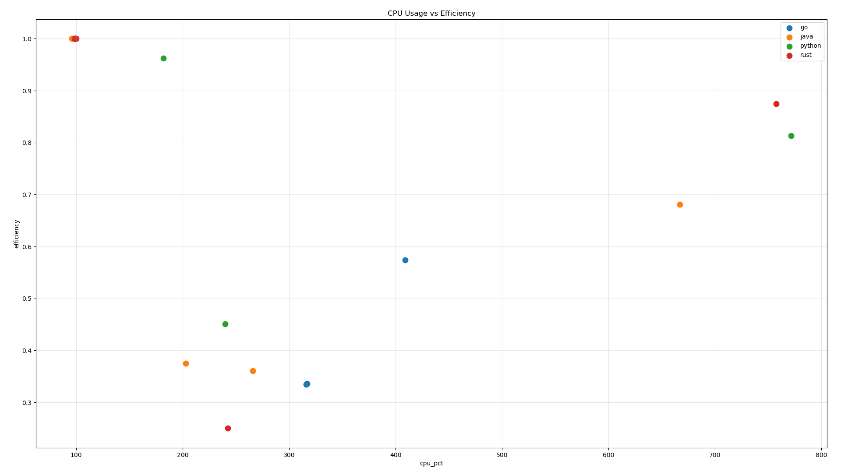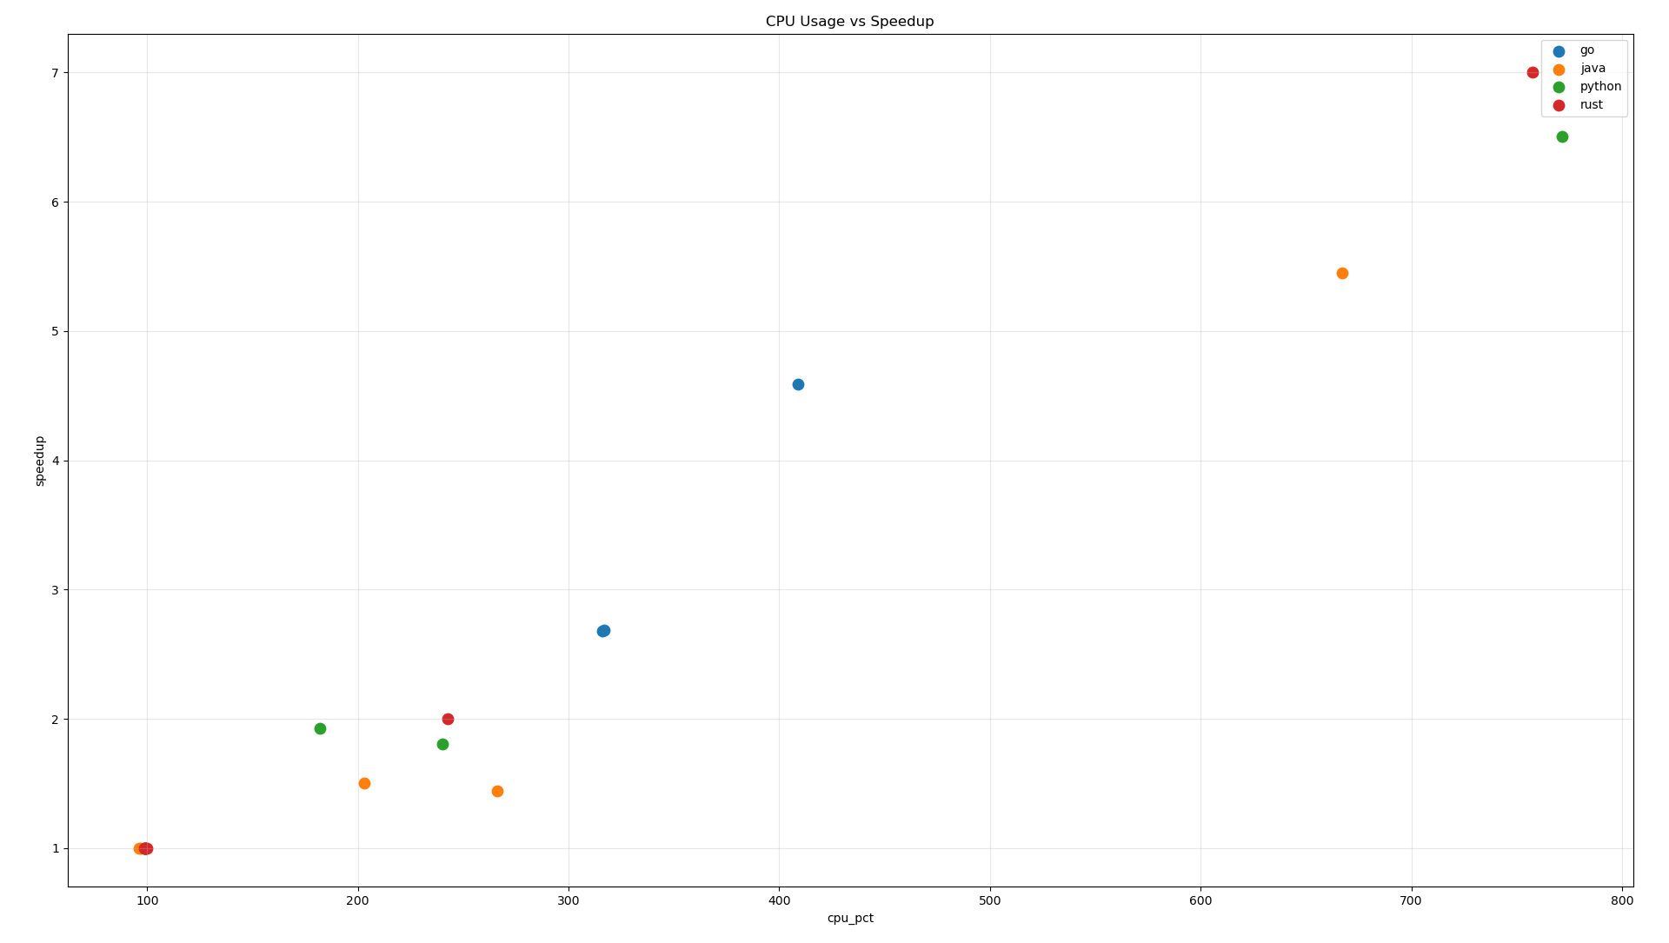
(a) (b)
Figure 4. Scatter Plot CPU: (a) CPU vs Efficiency; (b) CPU vs Speedup
Across all languages, CPU utilization exhibits a non-linear relationship with performance. Rust and Java demonstrate the most favorable conversion of CPU residency into parallel efficiency and speedup. Both languages typically operate within 90–120% CPU residency, achieving high efficiency and near-ideal speedup. Rust benefits from predictable thread scheduling and the absence of garbage collection, while Java shows strong post–warm-up throughput enabled by JIT compilation.
Go operates at higher CPU residency (300–420%) due to user-space scheduling and goroutine multiplexing. Although this results in moderate speedup, efficiency remains noticeably lower than Rust and Java for equivalent CPU usage. Python displays the widest variance: Low CPU, low efficiency, synchronization-bound workloads where IPC overhead dominates; High CPU, moderate efficiency, compute-bound multiprocessing workloads where CPU consumption includes process-switching overhead and data serialization costs.
Overall, higher CPU% does not imply higher performance. Only Rust and Java convert CPU residency into effective speedup. Go incurs scheduling penalties, while Python’s multiprocessing often inflates CPU usage without equivalent computational gain.
    - Memory Footprint vs Performance (Efficiency & Speedup)
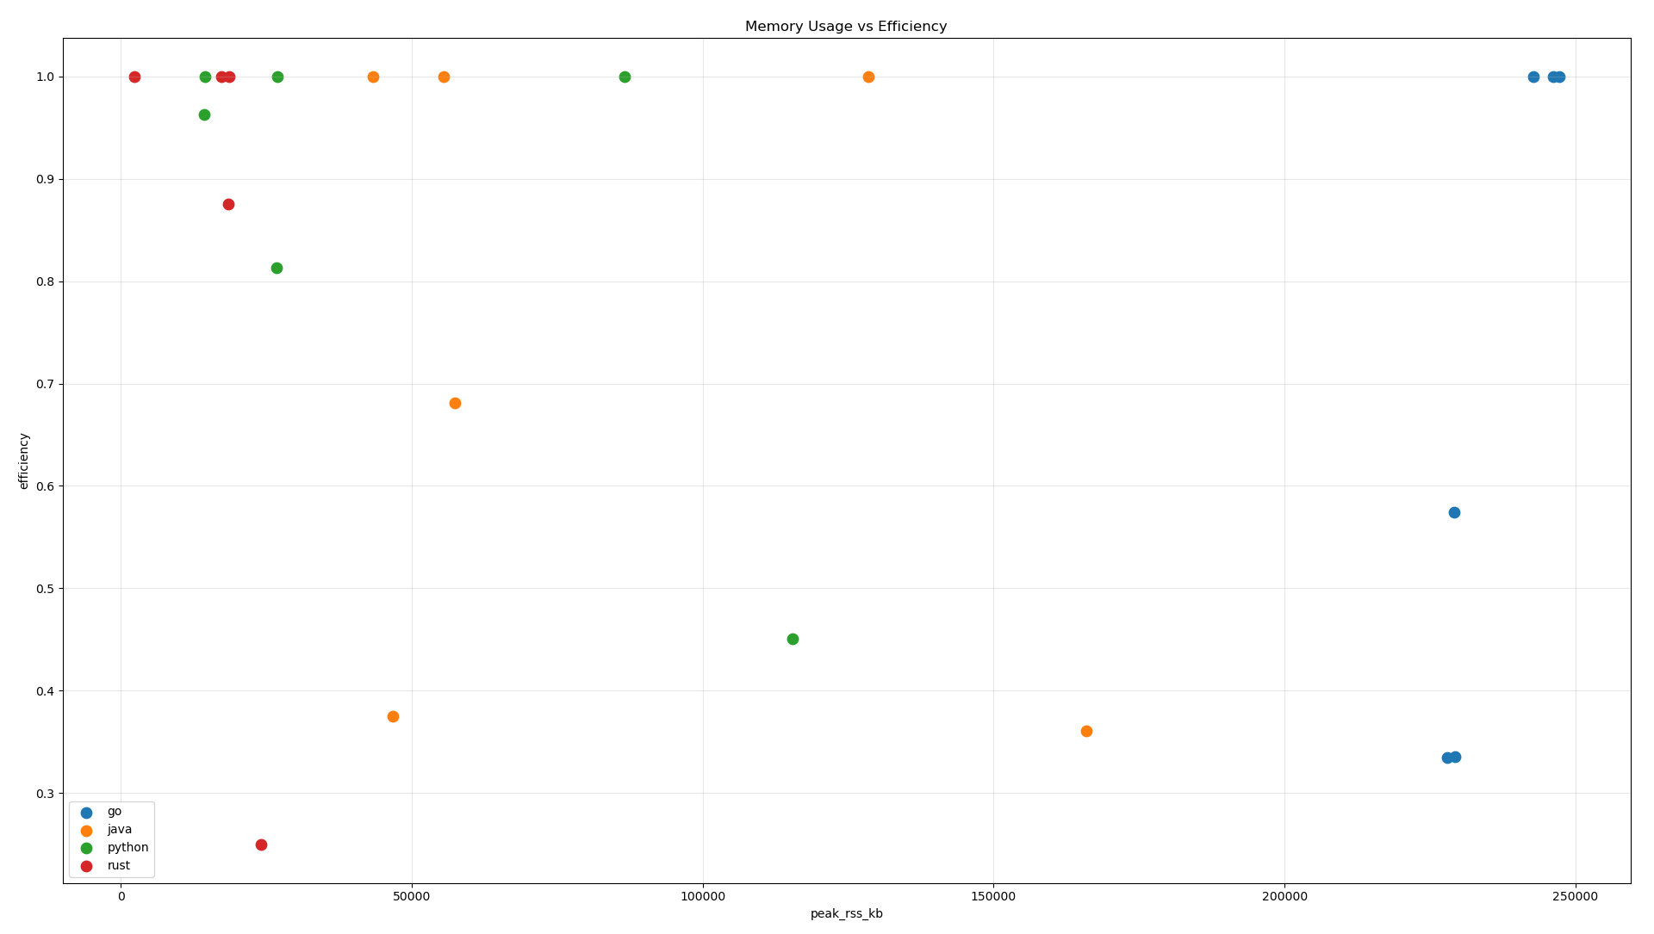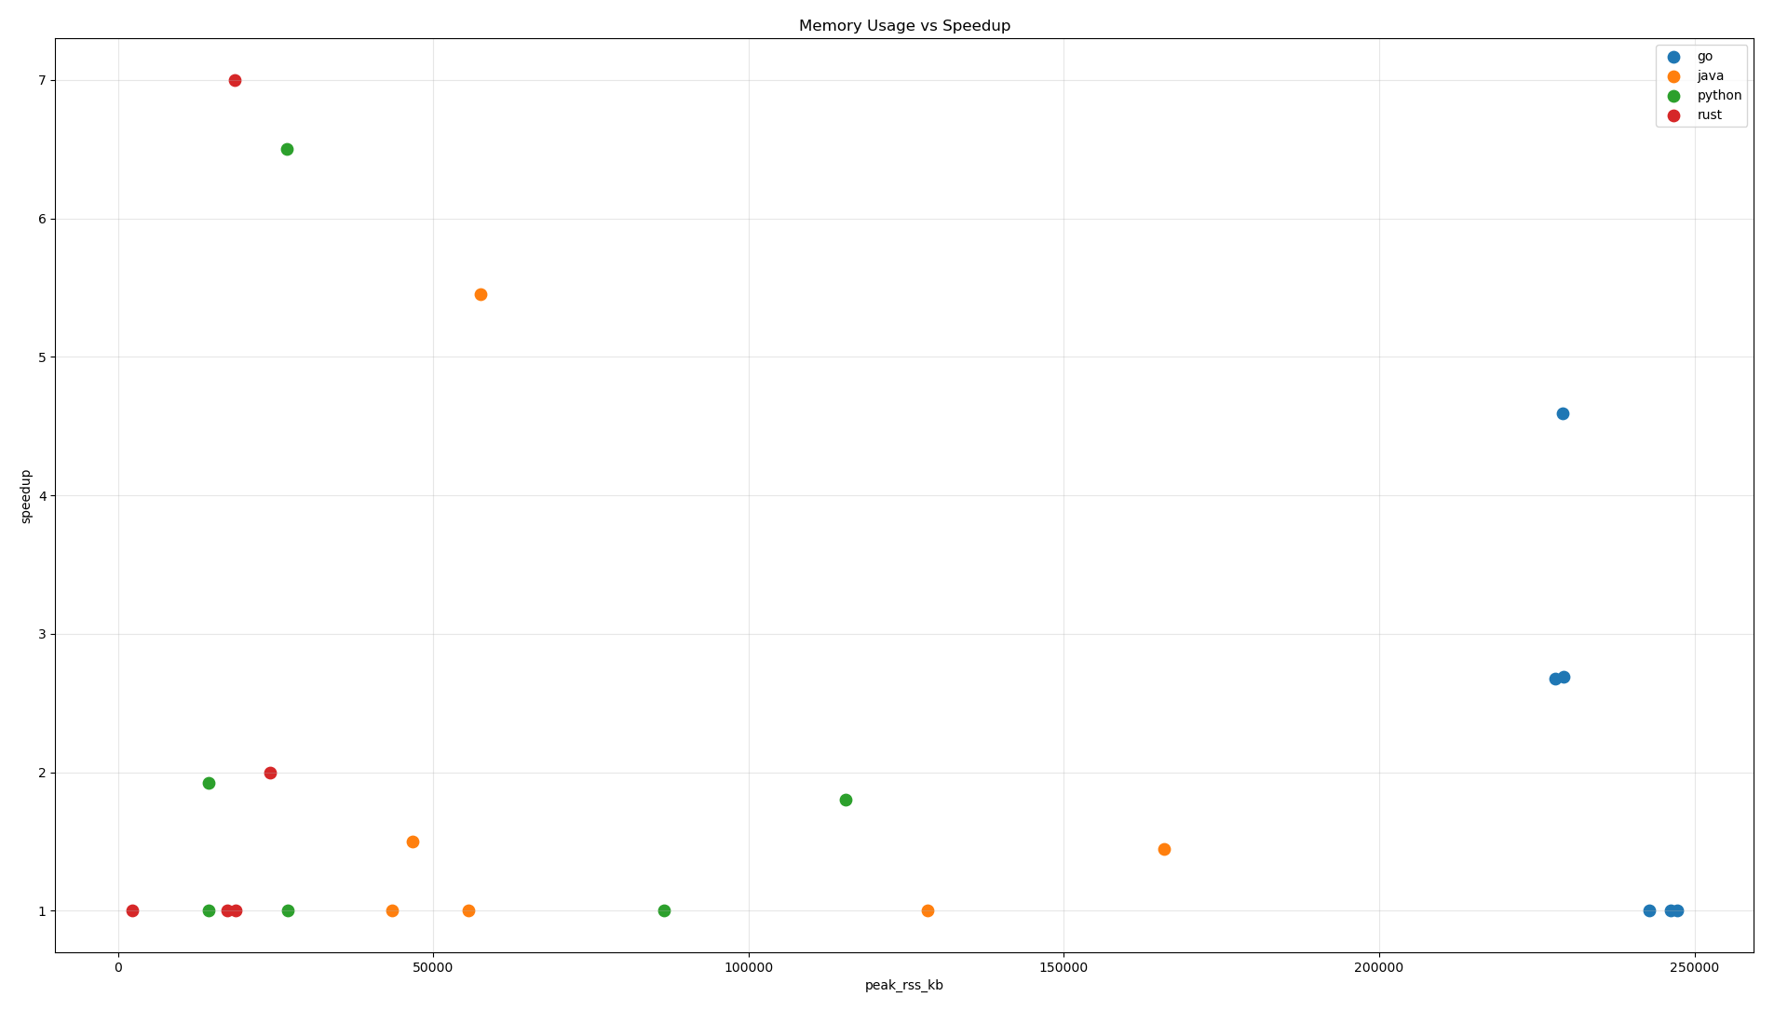
(a) (b)
Figure 5. Scatter Plot Memory RSS: (a) Memory vs Efficiency; (b) Memory vs Speedup
Memory consumption shows even stronger differentiation across languages. Rust consistently achieves the best results: extremely low memory footprint paired with the highest efficiency and speedup values. Its ownership-based memory model and predictable allocation behavior minimize overhead across all workloads.
Go exhibits significantly higher RSS, often exceeding 200 MB, due to goroutine stack management and garbage-collected heap growth. Despite this, Go retains mid-level efficiency, indicating that high memory usage does not directly degrade performance but contributes to scheduling and GC overhead.
Java’s memory footprint rises sharply in memory-intensive workloads, correlating with falling efficiency beyond $p=4$ due to increased garbage-collection activity and object-allocation churn. Python’s multiprocessing shows a clear pattern: higher memory usage (from process replication and shared-buffer duplication) correlates with weaker speedup, especially for synchronization-heavy workloads.
Across all languages, increasing memory footprint tends to reduce speedup, with Rust being the primary exception due to minimal runtime overhead.
  - Variability & Stability Analysis
This section evaluates the stability of execution time across repeated runs and quantifies runtime variability for each language–workload pair. The analysis uses the ten-run deep-replication results from Phase 2, computing three statistical indicators for each configuration: Variance ($σ^{2}$), sensitivity to runtime perturbations; Standard Deviation ($σ$), the absolute magnitude of jitter; Coefficient of Variation ($CV=σ/mean$) normalized variability independent of scale. A low CV indicates stable, predictable execution, while high CV signals runtime turbulence such as GC bursts, process jitter, or scheduler imbalance.
    - Execution-Time Dispersion Across Languages
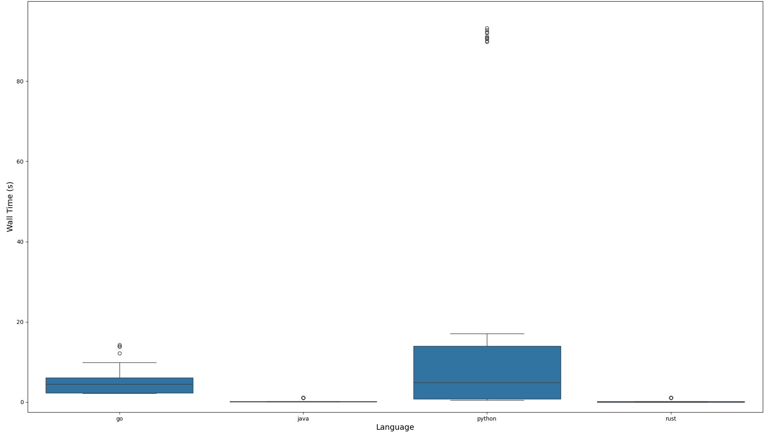
Figure 6. Boxplot of Wall-Time Variability per Language
Across all workloads, Rust exhibits the lowest variability, with CV values approaching zero. This reflects its static execution model, absence of garbage collection, and predictable OS-thread mapping. Rust’s performance is tightly clustered across all repeats, even for high-parallel configurations.
Go demonstrates moderate stability. Its user-space scheduler introduces slight scheduling noise, especially at higher worker counts, but variability remains within acceptable bounds. The goroutine model produces consistent throughput trends, though GC cycles occasionally create small timing fluctuations.
Java displays strong stability after warm-up, but exhibits noticeable jitter in memory-intensive workloads due to periodic garbage-collection events. While steady-state runs are predictable, GC pauses introduce tail latency in some repetitions, elevating CV values.
Python shows the highest variability across all workloads. The multiprocessing model incurs OS-level scheduling variance, process creation overhead, IPC latency, and queue contention. These factors create substantial scatter between runs, especially for synchronization-heavy workloads. CV values frequently exceed the threshold seen in compiled languages.
    - Variability Under Compute-, Memory-, and Sync-Bound Load
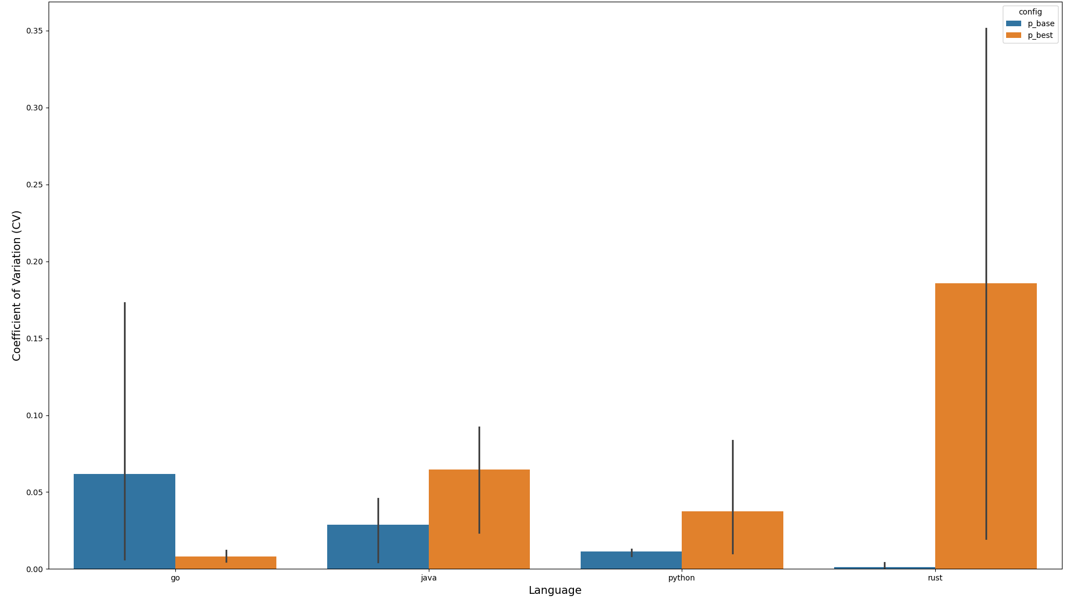
Figure 7. CV Comparison for p=1 and p=p_best Across Workloads
Compute-bound workloads (matrix multiplication) display low variability for all compiled languages. Rust and Java exhibit the lowest dispersion, while Go shows modest jitter due to goroutine scheduling. Python remains the least stable, though variability is lower than in memory- or sync-bound tasks due to reduced IPC.
Memory-bound workloads (parallel sorting) amplify variance in Java and Python. Java’s object allocation and GC activity create noticeable spikes in execution time among repetitions. Python’s process-level concurrency generates additional buffer copying and IPC overhead, significantly increasing jitter.
Synchronization-bound workloads (producer–consumer pipelines) show the sharpest variability differences. Go maintains consistent performance, benefiting from lightweight channels and efficient context switching. Rust, however, suffers elevated variance at higher thread counts due to synchronization overhead. Python shows extreme variability, with CV values indicating unpredictable IPC behavior and queue contention.
    - Stability Gap Between p=1 and p=p_best
Figure 8. Delta-CV Between Sequential and Parallel Configurations
Comparing sequential and parallel modes reveals important scalability insights: Rust maintains stability even at $p=8$, with minimal increase in CV; Go incurs a modest rise in variability at higher p due to scheduler overhead but remains stable overall; Java transitions from low variability ($p=1$) to moderate variability ($p=p_best$), primarily due to GC amplification in parallel workloads; Python shows dramatic increases in CV when moving from $p=1$ to higher $p$, reflecting poor stability under process-based concurrency. This stability decomposition highlights the runtimes' internal behavior under scaling pressure and shows that high speedup does not necessarily imply predictable performance.
Across all workloads and languages, several clear stability patterns emerge: Rust is the most stable runtime, with minimal jitter and tight clustering across repetitions; Go offers consistent behavior, with minor variability due to scheduling overhead but strong predictability even under synchronization load; Java is stable on average, but memory- and sync-heavy tasks introduce GC-related fluctuations; Python is highly unstable, especially under multiprocessing, where variability is driven by process creation overhead, IPC delays, and queue contention.
These results emphasize that runtime predictability is as important as raw performance. Rust and Go provide the most stable concurrency behavior, Java maintains stability except under heavy memory pressure, while Python’s variability highlights fundamental limitations of process-based parallelism.
- Conclusions
This study conducted a reproducible cross-language benchmark of concurrency performance in Go, Rust, Java, and Python across compute-bound, memory-bound, and synchronization-bound workloads. Using a two-phase methodology—baseline scalability analysis (Phase 1) and deep replication under representative configurations (Phase 2)—the study provides a comprehensive view of how modern runtimes behave on multicore systems.
Results show that Rust delivers the strongest overall performance, achieving the best execution time, speedup, efficiency, and stability due to its ownership model and absence of garbage collection. Java performs competitively after warm-up, reaching near-ideal speedup in compute-bound tasks but experiencing efficiency loss under GC and allocation pressure. Go exhibits the most balanced scaling, offering predictable and stable performance across all workloads despite moderate scheduling overhead from goroutines. Python shows the weakest parallel gains, with multiprocessing, IPC, and memory duplication limiting both efficiency and stability—especially in synchronization-heavy workloads.
Correlation analysis indicates that high performance depends not only on parallelism but on how effectively each runtime converts CPU and memory resources into productive work. Rust and Java show the best resource-to-performance efficiency, Go trades higher memory usage for stable throughput, and Python incurs significant overhead for limited gains. Variability analysis further highlights major differences in predictability: Rust and Go are consistently stable, Java moderately stable, and Python highly variable.
While limited to single-machine experiments and three workloads, this research provides practical, empirically grounded insights into the trade-offs of contemporary concurrency models and supports informed language selection in parallel software development.
- References
[1] M. A. N. Al-hayanni, F. Xia, A. Rafiev, A. Romanovsky, R. Shafik, and A. Yakovlev, “Amdahl’s law in the context of heterogeneous many-core systems – a survey,” IET Comput. Digit. Tech., vol. 14, no. 4, pp. 133–148, 2020, doi: https://doi.org/10.1049/iet-cdt.2018.5220.
[2] C. Poolla and R. Saxena, “On extending Amdahl’s law to learn computer performance,” Microprocess. Microsyst., vol. 96, p. 104745, 2023, doi: https://doi.org/10.1016/j.micpro.2022.104745.
[3] W. Crichton and S. Krishnamurthi, “Profiling Programming Language Learning,” Proc ACM Program Lang, vol. 8, no. OOPSLA1, Apr. 2024, doi: 10.1145/3649812.
[4] G. Schryen, “Speedup and efficiency of computational parallelization: A unifying approach and asymptotic analysis,” J. Parallel Distrib. Comput., vol. 187, p. 104835, 2024, doi: https://doi.org/10.1016/j.jpdc.2023.104835.
[5] P. Diehl, M. Morris, S. R. Brandt, N. Gupta, and H. Kaiser, “Benchmarking the Parallel 1D Heat Equation Solver in Chapel, Charm++, C++, HPX, Go, Julia, Python, Rust, Swift, and Java,” in Euro-Par 2023: Parallel Processing Workshops, D. Zeinalipour, D. Blanco Heras, G. Pallis, H. Herodotou, D. Trihinas, D. Balouek, P. Diehl, T. Cojean, K. Fürlinger, M. H. Kirkeby, M. Nardelli, and P. Di Sanzo, Eds., Cham: Springer Nature Switzerland, 2024, pp. 127–138. doi: 10.1007/978-3-031-48803-0_11.
[6] L. Cheeseman et al., “When Concurrency Matters: Behaviour-Oriented Concurrency,” Proc. ACM Program. Lang., vol. 7, no. OOPSLA2, 2023, doi: 10.1145/3622852.
[7] C. Menard et al., “High-performance Deterministic Concurrency Using Lingua Franca,” ACM Trans Arch. Code Optim, vol. 20, no. 4, Oct. 2023, doi: 10.1145/3617687.
[8] C. C. Din, R. Hähnle, L. Henrio, E. B. Johnsen, V. K. I. Pun, and S. L. T. Tarifa, “Locally Abstract, Globally Concrete Semantics of Concurrent Programming Languages,” ACM Trans Program Lang Syst, vol. 46, no. 1, Mar. 2024, doi: 10.1145/3648439.
[9] X. Yuan and J. Yang, “Effective Concurrency Testing for Distributed Systems,” in Proceedings of the Twenty-Fifth International Conference on Architectural Support for Programming Languages and Operating Systems, New York, NY, USA: ACM, Mar. 2020, pp. 1141–1156. doi: 10.1145/3373376.3378484.
[10] P. Y. Abhinav, A. Bhat, C. T. Joseph, and K. Chandrasekaran, “Concurrency analysis of go and java,” Proc. 2020 Int. Conf. Comput. Commun. Secur. ICCCS 2020, 2020, doi: 10.1109/ICCCS49678.2020.9277498.
[11] R. Jung, J. H. Jourdan, R. Krebbers, and D. Dreyer, “Safe systems programming in Rust,” Commun. ACM, vol. 64, no. 4, pp. 144–152, 2021, doi: 10.1145/3418295.
[12] D. J. Pearce, “A Lightweight Formalism for Reference Lifetimes and Borrowing in Rust,” ACM Trans Program Lang Syst, vol. 43, no. 1, Apr. 2021, doi: 10.1145/3443420.
[13] S. Klabnik and C. Nichols, The Rust Programming Language, 2nd ed. No Starch Press, 2023.
[14] P. Chaudhary, L. Agrawal, and A. Ali, “Modern Programming Languages ? Characteristics and Recommendations for Instruction,” Issues Inf. Syst., vol. 26, no. 2, pp. 281–291, 2025, doi: 10.48009/2_iis_122.
[15] M. Rogowski, S. Aseeri, D. Keyes, and L. Dalcin, “mpi4py.futures: MPI-Based Asynchronous Task Execution for Python,” IEEE Trans. Parallel Distrib. Syst., vol. 34, no. 2, pp. 611–622, 2023, doi: 10.1109/TPDS.2022.3225481.
[16] Md. N. Morshed and P. Roy, “Go vs. Java: A Detailed Performance Analysis in Concurrent Programming,” in 2024 1st International Conference on Advances in Computing, Communication and Networking (ICAC2N), 2024, pp. 1800–1804. doi: 10.1109/ICAC2N63387.2024.10894767.
[17] G. Zeng, “Performance analysis of parallel programming models for C++,” J. Phys. Conf. Ser., vol. 2646, no. 1, 2023, doi: 10.1088/1742-6596/2646/1/012027.
[18] L. Nigro, “Performance of Parallel K-Means Algorithms in Java,” Algorithms, vol. 15, no. 4, 2022, doi: 10.3390/a15040117.
[19] P. Mroczek, J. Mańturz, and M. Miłosz, “Comparative analysis of Python and Rust: evaluating their combined impact on performance,” J. Comput. Sci. Inst., vol. 35, pp. 137–141, June 2025, doi: 10.35784/jcsi.7050.
[20] T. G. Robertazzi and L. Shi, “Amdahl’s and Other Laws,” in Networking and Computation, Cham: Springer International Publishing, 2020, pp. 139–149. doi: 10.1007/978-3-030-36704-6_6.
[21] J. Arora, S. Westrick, and U. A. Acar, “Efficient Parallel Functional Programming with Effects,” Proc ACM Program Lang, vol. 7, no. PLDI, June 2023, doi: 10.1145/3591284.
[22] J. Arora, S. Westrick, and U. A. Acar, “Provably space-efficient parallel functional programming,” Proc ACM Program Lang, vol. 5, no. POPL, Jan. 2021, doi: 10.1145/3434299.
[23] L. Pons, S. Petit, and J. Sahuquillo, “Advanced resource management: A hands-on master course in HPC and cloud computing,” J. Parallel Distrib. Comput., vol. 202, p. 105091, 2025, doi: https://doi.org/10.1016/j.jpdc.2025.105091.
[24] T. Newhall, K. C. Webb, V. Chaganti, and A. Danner, “An introductory-level undergraduate CS course that introduces parallel computing,” J. Parallel Distrib. Comput., vol. 199, p. 105044, 2025, doi: https://doi.org/10.1016/j.jpdc.2025.105044.
[25] L. Liu, T. Millstein, and M. Musuvathi, “Safe-by-default Concurrency for Modern Programming Languages,” ACM Trans. Program. Lang. Syst., vol. 43, no. 3, pp. 1–50, 2021, doi: 10.1145/3462206.
[26] N. Ahmed, A. L. C. Barczak, M. A. Rashid, and T. Susnjak, “A parallelization model for performance characterization of Spark Big Data jobs on Hadoop clusters,” J. Big Data, vol. 8, no. 1, p. 107, Dec. 2021, doi: 10.1186/s40537-021-00499-7.
[27] V. Jarlow, C. Stylianopoulos, and M. Papatriantafilou, “QPOPSS: Query and Parallelism Optimized Space-Saving for finding frequent stream elements,” J. Parallel Distrib. Comput., vol. 204, p. 105134, 2025, doi: https://doi.org/10.1016/j.jpdc.2025.105134.
[28] R. Quislant, E. Gutierrez, and O. Plata, “Exploring multiprocessor approaches to time series analysis,” J. Parallel Distrib. Comput., vol. 188, p. 104855, 2024, doi: https://doi.org/10.1016/j.jpdc.2024.104855.
[29] Y. Wang, H. Lin, B. Wei, J. Gao, and W. Ji, “Optimizing General Sparse Matrix-Matrix Multiplication on the GPU,” ACM Trans Arch. Code Optim, Nov. 2025, doi: 10.1145/3774654.
[30] R. Cárdenas, P. Arroba, and J. L. Risco-Martín, “Lock-free simulation algorithm to enhance the performance of sequential and parallel DEVS simulators in shared-memory architectures,” J. Parallel Distrib. Comput., vol. 203, p. 105105, 2025, doi: https://doi.org/10.1016/j.jpdc.2025.105105.
[31] D. C. Montgomery, Design and analysis of experiments, 10th ed. Wiley, 2020.

